Definition:

该产品的目的是使用户快速，直观，准确的了解到不同地区对某件事物各自的态度。现有的语义分析算法已经十分普及，但大多数关于语义分析的应用主要功能是对自然语言进行态度分析，而该应用是对某一地区的多个个体进行语义分析并且获得该地区的态度，另外在对自然语言分析的基础之上添加了可视化的功能，可以在地图上显示出各个地区对于某一事物的态度，这样可以使用户更加直观的了解到该地区是否支持某一事物。

Specification：

获取不同地区态度的主要方法是通过对某一地区内的tweeter用户所发表的tweets进行语义分析，从而获取该用户对于该事物的态度，由此可以获得一个-1到1之间的描述态度的数值，比如，当该数值<0时则表示negative， =0则表示中立态度，>0表示positive。然后再计算整个地区内所有用户对该事物态度的平均值，从而获得该地区对于某件事物的态度。接着再对该态度平均值进行分析以及分类，如果该地区态度的平均值为positive，则显示为笑脸表示支持态度，如果为negative，则显示为哭脸表示反对态度。通过这种方法计算出各个地区的平均态度值，并且在地图上的相应位置显示对应的态度图标。

Definition:

The propose of this product is to enable users to acquire attitude towards one specific event in different districts, faster, intuitively and accurately. The existing semantic algorithms are diffusive, however, the majority of those algorithms are focused on the attitude analysis of natural language. This application is to analysis the attitude of multi-individuals in one area and obtain the attitude of this area. Additionally, the function of visualization is appended based on the analysis of natural language, which means that attitudes towards one event in different districts will be displayed on the map, so that users can understand whether the district is supporting a certain event or not intuitively.

Specification：

The main method of capturing attitudes towards one specific event in different areas is to obtain the attitude of one tweeter customer at first by means of implementing semantic analysis to the tweets posted by that customer. There will be a integer, from -1 to 1, which is used to describe the attitude returned, for instance, if the returned integer is smaller than 0, then the attitude is negative, if the returned integer is equal to 0, the attitude is medium, and greater than 0 is positive. At the next step, collect the attitudes(an integer from -1 to 1) of an event of all the tweeter customers in one region, and calculate the average. In this way, the attitude of one district can be obtained. Next, analysis and classify the average, if the average is smaller than 0, which means the attitude is negative, then a crying face will be displayed, and if the average if greater than 0, a smiling face will be displayed. Repeat this process to more regions, so that the attitudes described by emoji of each area can be seen on the map.

Definition:

The incremental model, which is developed through each step of analysis, design, implementation, testing, and maintenance, is a software development program that decompresses demand into independent modules of the software development cycle.

Each iteration consists of requirements, design, coding and testing phase. Before all designed functions are built into the system, we add a new function to each later version. We started to implement our application when the first increment appeared, which is the basic function of the application, then we added new functions to and optimized our application in following iterations.

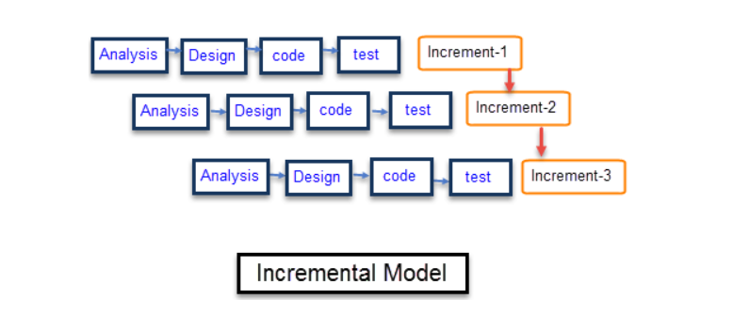

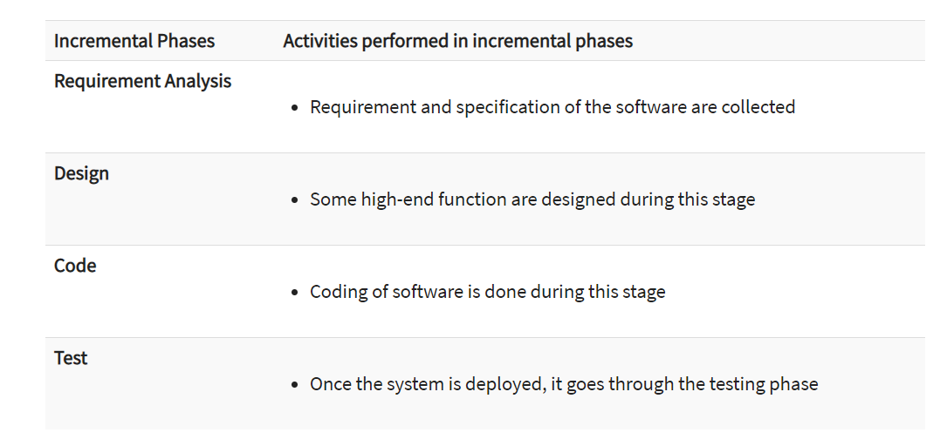

<https://www.guru99.com/what-is-incremental-model-in-sdlc-advantages-disadvantages.html>

specification:

1. why did we choose incremental model

Firstly, our team is not professionally trained. This means that we might run into some unexpected challenge during the implementation process. Thus, incremental model is very suitable for our team, since this development pattern is flexible and if we want to change our requirements or function, it does not cost much. Additionally, changes can be done during the whole process of development, so that we can adjust our plan based on the actual situation.

Secondly, we have limited time to develop our application. By incremental model, we can design the basic function of our application quickly and start to implement it as soon as possible. Besides, errors are easier to be figured out, since we can test our code in each iterations, each function.

1. how did we implement the incremental model
2. core function:

In the first iteration, we analyzed and designed the core function of our application, which is to search a single word on tweeter and capture related tweets, then conduct semantic analysis on those tweets.

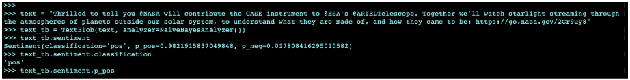

1. allow users to search

In the second iteration, we established a searching box in the front-end, which allows users to input the key words they want to search.

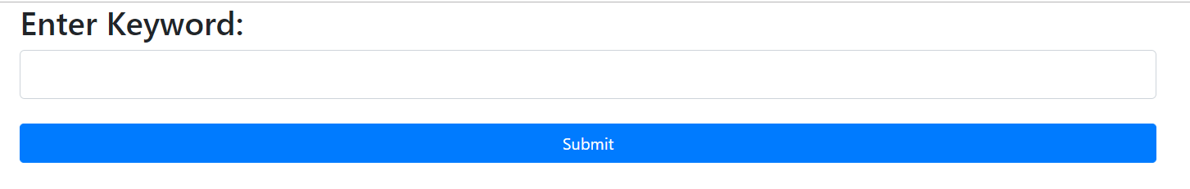

1. front-end calculation

In the third iteration, we returned the result of sentiment analysis to front-end, and calculate the attitude of each tweets, print those tweets and attitude in console.

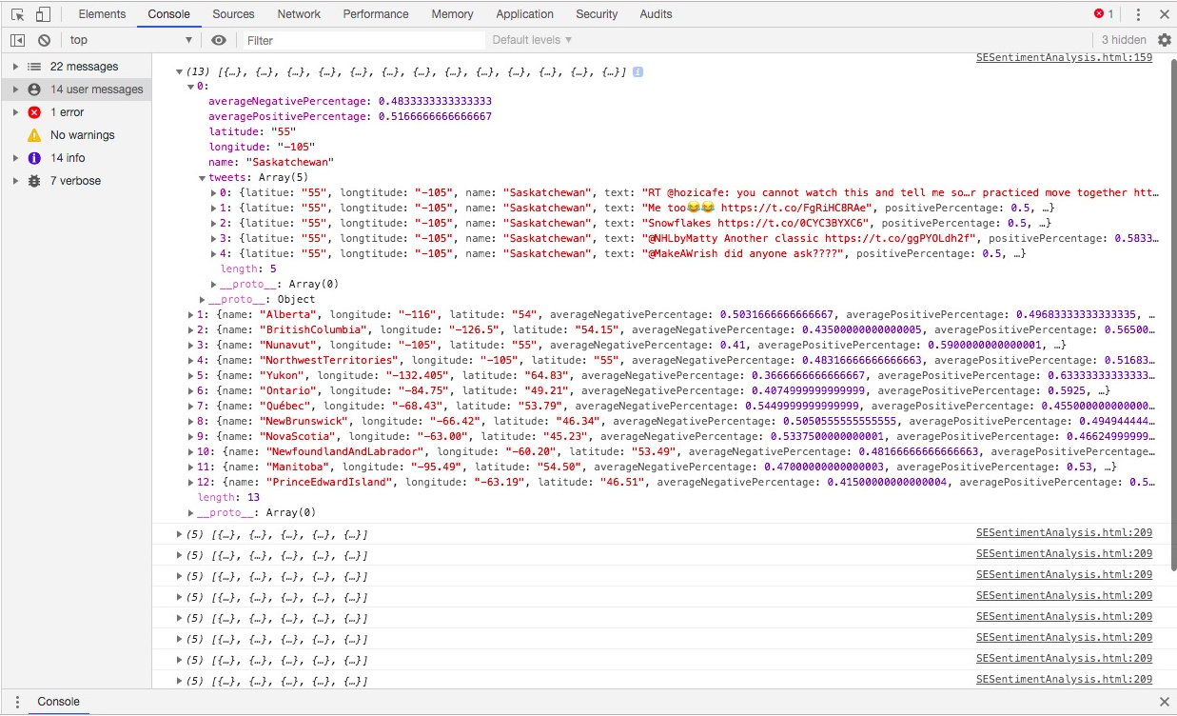

1. display

In the final iteration, we display the data in the console, including showing appropriate emoji on the map and listing the tweets.

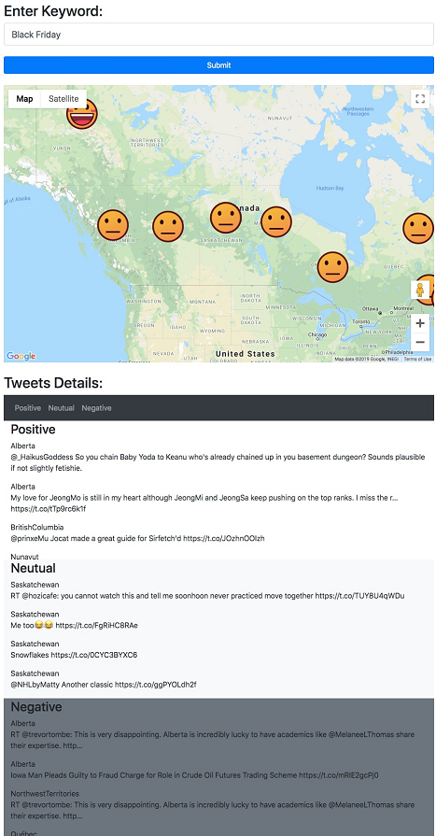

Architecture:

The Model-View-Controller (MVC) model is an architectural pattern that splits applications into three basic logical components: models, views, and controls. All components are designed specifically for the development of specific aspects of the application. In industry-standard web development framework, MVC model is one of the most frequently used.

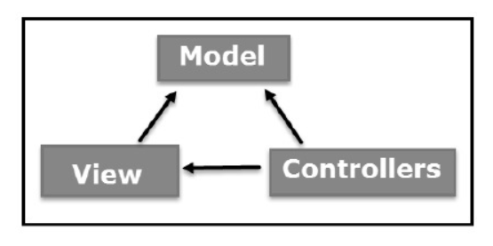

<https://www.tutorialspoint.com/mvc_framework/mvc_framework_introduction.htm>

ModelThe component of the model is responsible for all the data-related logic used by the user. This can represent both the data that is being transferred between View and Controller components, as well as all other  business logic-related data.. For example, customers would retrieve the customer information from the database, process it and return it back to the database, or use it to render the data.

viewThe view component is related to all the UI interface of the application. For example, the client view include all the UI components that attached to the end user, such as text boxes, the dropdowns, and so on.

ControllerThe controller is an interface between the model and the view, processes all the business logic and incoming requirements and data is to be operated using model component, and display the final output using views. In the customer controller, for example, all customer view interactions and inputs are processed and the database is updated with the customer model. Customer data is checked using the same controller.